Examining environmental factors that contribute to juvenile Chinook salmon growth in the Salmon River Basin, Idaho

**Abstract**

Over the past century, salmon runs in the Columbia River have been reduced to 6-7% of their historical size. The Salmon River in Idaho is a tributary of the Columbia River, and provides spawning habitat for a range of ESA (Endangered Species Act) threatened salmonids including Chinook salmon (*Oncorhynchus tshawytscha*). Despite having similar outmigration timing, and experiencing the same downstream conditions, different salmon bearing streams in the Salmon River Basin have significantly different juvenile Chinook survival rates through the Columbia River hydropower system. To understand how conditions in natal streams affect juvenile Chinook, somatic growth from otoliths was measured in seven streams in the Salmon River Basin from 2003-2016 in conjunction with in-stream environmental monitoring data and publicly available local climate data.

Our study indicates that El Niño/La Niña weather patterns, stream temperature, flow, and stream productivity patterns all have significant effects on the somatic growth rate of Chinook in the Salmon River Basin. Stream temperature was positively correlated with Chinook somatic growth within the observed temperature range. Somatic growth was highest during the hottest part of the summer, and steadily decreased over the course of late summer into fall. The streams that were consistently colder than the others had consistently lower growth across years. however, streams that were warmer on average did not necessarily show a trend of consistently higher somatic growth relative to others. Fish density showed a weakly negative relationship with growth. In years with higher instream chinook densities, growth was somewhat depressed compared to low density years, possibly indicating a density dependent effect on growth. Somatic growth was highest during years with mild or nonexistent El Niño/La Niña conditions, and the lowest during years with extreme El Niño or La Niña conditions. The results suggest that increased weather variability under predicted climate change scenarios may adversely affect Chinook growth in the upper Columbia River tributaries.

**Introduction**

Salmon populations on the west coast of North America have declined precipitously over the past century(ref). The Columbia River historically supported salmon runs between 60-80 million fish(ref), but as of the year 2000 has been reduced to 6-7% of historical values ([Gresh et al. 2000](https://docs.google.com/document/d/1ZkM-rT4erfvl-i7Sb1Fm-AW_uxgLn8D0WHNP3EbiUxY/edit" \l "heading=h.35nkun2)). Some of the only fully-wild populations of salmon are in the Salmon River Basin in Idaho. The Salmon River supports wild ESA (Endangered Species Act) threatened stocks of spring and summer run chinook salmon and steelhead, as well as the terminus of North America’s longest sockeye migration at Redfish Lake.

Success during early life stage/rearing can have long lasting effects on the chances of survival during the subsequent life stages. Larger fish often have an increased chance of surviving the downstream migration and estuary phase relative to smaller fish of the same cohort (ref). Being able to tie environmental factors such as productivity, temperature, and climate to growth is extremely useful. It allows for a better understanding of current trends in salmon production in various streams in the region, as well as providing insight into growth under predicted climate change scenarios. The Salmon River provides an excellent study area to examine how different stream conditions affect the growth of the salmonids rearing in it. The timespan of the dataset makes this study unique. Many papers examine the effect of the rearing environment on chinook growth, but very few with 14 consecutive years of data.

The study began in earnest in 2003 with continuous data through 2016. The goals of this study are:

1) To pair as much biotic and abiotic information from the streams as possible with instream chinook growth rates.

2) To model growth with corresponding environmental factors in and around the streams to try to pair variability in growth with specific environmental metrics.

3) To examine how different water temperature and climate regimes affect chinook somatic growth.

4) To extrapolate on how predicted temperature increases under predicted climate change regimes may affect chinook somatic growth.

Study Area:

The Salmon River is one of the largest rivers in the continental US that has an undammed mainstem. Chinook and steelhead fry rear together in streams before beginning out-migrations down the Salmon River, Snake River, and eventually through the Columbia River hydropower system. Out-migrating fish must pass through the four Lower Snake River Dams, and the four Lower Columbia River Dams in order to reach the Pacific Ocean.

The Salmon River Basin relies primarily on rain as a source of water for streams(ref), with snowmelt supplementing some streams more than others. Different tributaries are fed from a mixture of snowmelt and rainwater that contribute to forming markedly different temperature regimes in various streams throughout the basin(ref). Under predicted future climate change scenarios, a greater proportion of stream water is expected to originate from rain water instead of snowpack(ref). Not only will this cause greater variability in day to day stream flow, but water temperatures will also increase(ref), as streams lose cold snowmelt inputs. Overall hotter summers will also contribute to water temperatures that are higher than what is currently experienced(ref).

In addition to this patchwork of stream temperatures, there are also large differences in productivity between streams that are geographically very close to each other (Sanderson et al. 2009). These high altitude headwater streams are almost all nutrient limited (Sanderson et al. 2009). Among these nutrient limited streams, different streams in the basin are limited by different nutrients (Sanderson et al. 2009), likely as a result of different levels of mineral leaching from the underlying substrate as well as different inputs of allochthonous biological material.

**Methods**

**Fish collection:**

For this study, seven streams across the Salmon River Basin in Idaho were chosen for sampling: Marsh Creek, Cape Horn Creek, Elk Creek, Bear Valley Creek, Valley Creek, Lake Creek, and South Fork Salmon River. These streams are part of the on-going and long-term PIT tagging project in the region. (Figure Put a map with the 7 sites and maybe dams)The specific streams were chosen from the larger set of PIT tagged streams in order to represent a range of different average stream temperatures, and a range of different stream productivities. Juvenile Chinook were caught via electroshocking during the summers of 2003-2016 (Figure 1). Each year fish were collected from the same stretches of stream where fish for PIT tagging were caught. The majority of fish were caught in early September, in order to be able to examine a larger amount of summer growth. Due to sampling restrictions, in some years fish were only collected in mid-July through mid-August (Figure 1).

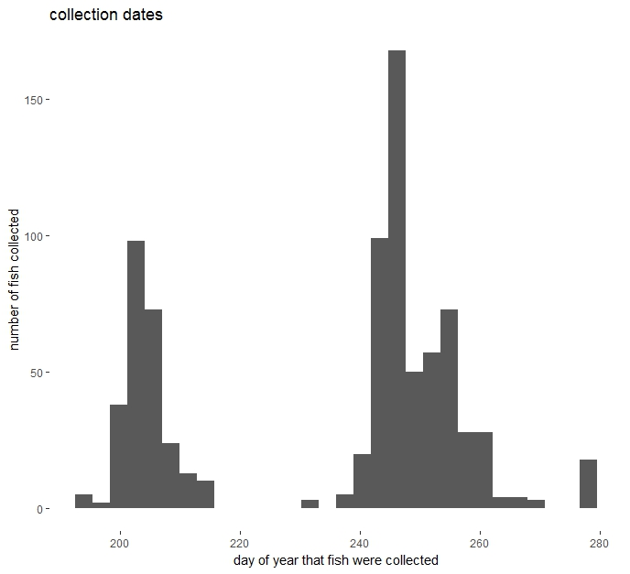

Figure 1. Collection dates for Chinook salmon and concurrent environmental samples from 2003-2016 (n = 936). Most fish were collected in early to mid-September, with a smaller number collected in July and August.

On average, about 10 Chinook and 10 steelhead were caught per stream, per year. A total of 999 Chinook were used for this study. Of those, 978 were juvenile Chinook that had hatched in spring of their collection year. There were 21 Chinook collected that were precocious males, meaning that they were sexually mature Chinook that had hatched the spring of the previous year, but stayed in the stream for their entire life cycle. They were on average larger (Fork length 112.4mm) compared to fork length of 66.4mm for sub-yearling juveniles. After collection, fish were euthanized with tricaine methanesulfonate (MS-222) and frozen until processing. Each fish was wet weighed to the nearest 0.1g, and fork length and total length were measured to the nearest 1mm. The methods used were almost identical to those used in (Chittaro et al. 2018 and Zabel et al. 2009). Otoliths were extracted, mounted on microscope slides, polished using grinding and polishing slurries (Buehler 320 grit silica carbide, 5 grit alumina oxide, and 1 micron micropolish). Otoliths were polished until cores were visible and daily increments were visible (Chittaro, Zabel, Beckman, Larsen, & Tillotson, 2015; Volk, Bottom, Jones, & Simenstad, 2010). Digital images were captured using a camera (Leica DFC450) mounted to a compound scope (Zeiss). Image Pro Plus Version 7 (Mediacybernetics) was used to analyses daily growth increments from the images. We measured distance from otolith core to edge (i.e., otolith radius at time of capture, Oc) and to as many increments as possible. This resulted in a dataframe whereby each fish had 2 columns:

1) a column of otolith radii and

2) a column of increment widths.

We calculated a 3rd column of fork length at a time prior to capture. Specifically, for each otolith radius (Oa) we estimated fork length (FLa) using the quadratic equation with biological intercept reported in Zabel et al. (2010)

FLa = ((0.096*(Oa-Ointercept))+(0.000053*((Oa-Ointercept)*(Oa-Ointercept)))) + FLintercept

FLa = ((0.096 * (Oa - 95.8)) + (0.000053 * ((Oa - 95.8) * (Oa - 95.8)))) + 21.6

Where mean fish length at hatching (FLintercept) was 21.6mm for spring/summer Chinook and mean otolith radius intercept (Ointercept) at hatching was 95.8 microns for spring/summer Chinook. To constrain the models to pass through these intercepts, we first subtracted the intercept from each individual’s fork length and otolith radius. Using this column of estimated fork lengths we then will calculate average daily growth rate (mm/day) for an individuals’ last 7, 14, 21, and 28 days of life (a), Average daily growth=(FLc-FLa)/a7 to 28days of growth was a reasonable amount of time to estimate growth while in rearing habitats.

It should be noted that the growth rate estimate used throughout this study is the average daily growth from the last 7 days prior to capture/death. Corrected values accounting for different dates of capture and size of fish were created and used during modeling to account for these confounding effects.

**Environmental data collection:**

Temperatures were collected with HOBO temperature loggers in each of the streams. Temperatures were recorded every 10 minutes, and from May to October for most years. Temperature data was not available for some streams earlier in the study. HOBOs collected temperature data in Bear Valley and Elk from 2008-2016, Cape Horn from 2009-2016, Lake from 2009-2016, Marsh, South Fork Salmon, and Valley from 2003-2016. Once data was retrieved, daily max, min, and mean temperatures were calculated (Figure 2). We compiled data on the El Niño and La Niña cycle (NOAA Climate Prediction Center; http://www.cpc.noaa.gov/products/analysis_monitoring/ensostuff/ensoyears.shtml) to examine the effect of larger scale, longer term climatic patterns on growth rate.

Chinook catch per unit effort was calculated each year during PIT tagging. Electroshocking crews recorded the length of stream that was sampled, along with the total numbers of chinook that were observed and caught. The catch per unit effort serves as a surrogate for fish density, since site specific density estimates were not available.

In order to examine stream productivity and food availability for fish, multiple metrics were collected:

Five sites were selected from each stream and marked on a GPS. Sites were selected to be similar to one another, in order or make comparisons more accurate. Each site was several hundred meters apart from the previous one. Every year, samples were collected from each site in the same location. Water chemistry was collected at every stream at least once a year, and often twice. Five water samples were taken each time a stream was sampled, one from each site. Acid washed and sterile 125mL bottles were used for collection, and single use 60mL syringes were used for water collection. Samples were frozen, and analyzed within a few months of collection by the University of Washington, School of Oceanography’s Chemical Oceanography Lab. Total phosphorus and total nitrogen were reported in micrograms per liter. In all, there were 1028 total nitrogen and total phosphorus samples taken. Values were averaged among the five sites for a given stream sampling event.

In order to examine stream productivity, ash-free dry mass and chlorophyll florescence per meter3 was measured to determine productivity per unit area of steam bed. During yearly sample collection, one rock was randomly selected from each site at each stream. Rocks were put on ice and driven back to the lab for processing. Each rock was thoroughly scrubbed and rinsed in order to remove all biomass. Rocks were measured for length, width, and height in order to calculate a rough volume for each rock. The rinsed water was subsampled and filtered onto glass fiber filters for AFDM (ash-free dry mass) and chlorophyll florescence analysis. AFDM samples were dried overnight in a 105 **°**F oven, weighed, and then ashed at 1000**°**F in a muff oven. AFDM per meter3 was back calculated from the subsampling volumes before being divided by the volume of each rock. Chlorophyll samples on filters were extracted in 10mL of HPLC grade acetone in a freezer overnight, before being subsampled and diluted in pure HPLC grade acetone. Florescence was calculated in a dark room using a TD 700 Fluorometer that was regularly calibrated. Blanks were run before and after analysis for quality assurance. . In all, there were 1391 AFDM and chlorophyll florescence samples taken. Values were averaged among the five sites for a given stream sampling event.

Prey availability was assessed using benthic and drift samples taken at each stream. Benthic samples were taken using a Hess Sampler and placed in250mL bottles filled with 95% ethanol. Drift samples were taken using drift nets set out for approximately 20 minutes. The total time the nets were in the water, water depth in the net, and flow were calculated in order to calculate water volume that was sampled for each drift sample. Samples were placed in 250mL bottles with 95% ethanol. Drift and benthic samples were analyzed by Rhithron Associates Inc. Generally, three benthic samples and two drift samples were collected at each stream during a sampling event. Several metrics were calculated from each sample. Total invertebrate biomass, the invertebrate density per unit area, and the Shannon-Wiener Index were calculated for various samples. Drift samples and benthic samples from a given stream sampling event were each averaged. Due to financial restraints, not every metric was calculated for every sample. In total, invert biomass was calculated for 219 drift samples and 220 benthic samples. 222 drift samples were analyzed for invertebrate density, and 185 benthic samples were analyzed for insect density and Shannon-Wiener Index.

**Pairing growth data with environmental data:**

Daily growth rates were synced to the individual calendar year dates and specific water temperatures when they were formed. This was possible since the date at which the last growth ring wa deposited (the date the fish was killed) was known. Dates for the previous rings could then be assigned and paired with temperature data from the same streams on the same days. It should be noted that this was only possible for the summer growth period in which the fish was killed. Previous summer growth for precocious male Chinook ≥1 years old could not have temperature data assigned to growth rings from previous years. Otolith growth from overwintering periods when growth was slow or non-existent cannot be measured, and thus dates cannot be matched to daily growth increments from previous years.

Otolith radius measurements were back-calculated from the otolith radius at time of death, so that fish size over time could be estimated. Environmental data was not available for every fish caught. When environmental data WAS collected at the same time as fish, all available data was paired to those fish. When environmental data was not collected at the same time as fish, those fish were not paired with any extra data. Unique identifiers were given to every fish at the time of collection, allowing all available environmental data to be synced from multiple sources to each fish when it was available.

Chinook growth rates were compared using generalized linear models (GLM). A total of 17 different environmental metrics were input into GLM models along with fish growth, stream, year, and day of year collected. AIC scores were used to evaluate model success at predicting variability in growth. Models with AIC values less than 2.0 apart from each other were considered indistinguishable.

A primary concern during the analysis was confounding effects from differences in collection date and fish size. Since fish were collected on different dates, and were different sizes. In order to account for this during the analysis, fish growth was standardized by fish size, and to the same window of time as calculated by day of year. Calculated growth rate was divided by the measured fork length at the time of capture. Separately, growth rate from the same 7 day window was used to create a growth estimate from the same window of days. Day of year 234-240 was used to calculate an average 7 day growth for that period of time (as opposed to last 7 days of growth which is what was primarily used for this study). Day of year 234-240 was chosen because the majority of the fish in the study have growth data that falls into this range. Of the 936 Chinook that were in the dataset, 624 (2/3) were collected after day of year 240, and thus daily increment data was available for the 234-240 range. Fish that were collected prior to day of year 240 were excluded from that analysis. Each of these separate corrections was added to the dataset and modeled separately in the same way as the original last 7 days of growth.

**Results**

Stream temperatures fluctuated yearly in an expected pattern. Peak temperatures were usually recorded in the last two weeks of July and the first two weeks of August. Across years CHO consistently had the lowest average temperatures, while VAL, ELK, and BVA consistently had the highest temperatures.

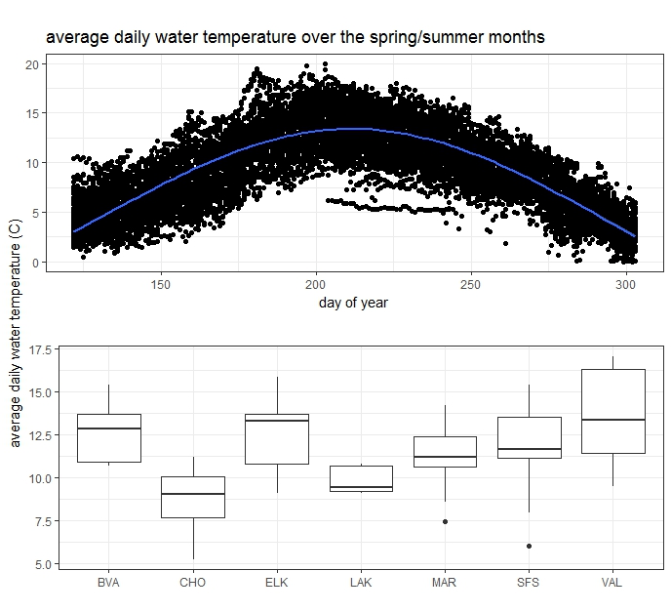

Figure 2. Top plot: Average daily water temperature in all 7 streams from early July to late September. Bottom plot: Average daily water temperatures in each stream from early July to late September.

Growth rate varied between both stream and year (Figure 3). ELK, LAK, and SFS had the highest growth, with VAL, MAR, and BVA having intermediate growth, and CHO experiences the lowest overall average growth.

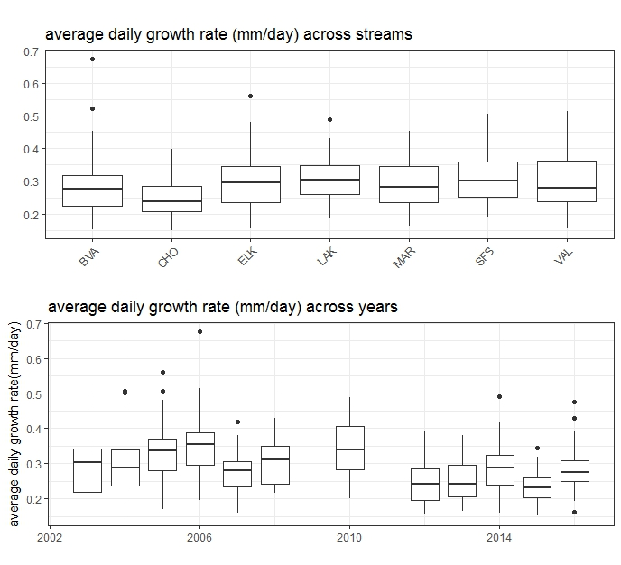

Figure 3. Top plot: Spacial differences in growth rate between the seven streams across all years of the study. Bottom plot: Temporal differences in growth across the seven streams. For both plots, growth rates were subsetted to day of year 240-260 in order to account for changes in growth over the summer months. 2009 and 2011 were excluded entirely since no fish were collected in those years between day of year 240-260. (Horizontal lines in the boxes represent median values, horizontal perimeters of the boxes represent the lower and upper quartiles, the vertical lines represent mimimum and maximum values, and black points are outliers.)

**Comparing growth data to environmental metrics**

For Chinook: A model that contained: the sampling year, the stream that was sampled, the day of year when the fish was sampled, the previous 3 months of el nino and la nina intensity values prior to fish capture, and total nitrogen concentration in the stream water at the time of capture, had the highest success at predicting average daily growth rates over a one week period prior to fish capture with an AIC value of -1,934.7.. Other variables that were present in the top ten models were total phosphorus and current el nino and la nina intensity values at the time of fish capture. Of the top ten models with the lowest AIC values, 4 of them included total phosphorus as a variable, and 5 included total nitrogen. Current el nino and la nina intensity values at the time of fish capture also was included in 5 of the of the top 10 models. The AIC values of the top ten models ranged from -1,934.7 to -1929.1 (Table 1.).

|  |  |  |  |  |  |  |  |  |
| --- | --- | --- | --- | --- | --- | --- | --- | --- |
| **year/stream** | **model parameters in top models explaining variability in growth** | | | | | | | **AIC score** |
|  | **year** | **stream** | **doy** | **oni** | **totN** | **totP** | **daily mean temp** |  |
| **all** |  |  |  |  |  |  |  | **-1932.58** |
| **2003** | **NA** |  |  |  |  |  |  | **-88.817** |
| **2004** | **NA** |  |  |  |  |  |  | **-101.804** |
| **2005** | **NA** |  |  |  |  |  |  | **-277.522** |
| **2006** | **NA** |  |  |  |  |  |  | **-256.608** |
| **2007** | **NA** |  |  |  |  |  |  | **-178.23** |
| **2008** | **NA** |  |  |  |  |  |  | **-90.3518** |
| **2009** | **NA** |  |  |  |  |  |  | **-132.074** |
| **2010** | **NA** |  |  |  |  |  |  | **-94.2707** |
| **2011** | **NA** |  |  |  |  |  |  | **-188.39** |
| **2012** | **NA** |  |  |  |  |  |  | **-188.39** |
| **2013** | **NA** |  |  |  |  |  |  | **-197.642** |
| **2014** | **NA** |  |  |  |  |  |  | **-188.94** |
| **2015** | **NA** |  |  |  |  |  |  | **-156.376** |
| **2016** | **NA** |  |  |  |  |  |  | **-156.376** |
| **LAK** |  | **NA** |  |  |  |  |  | **-286.066** |
| **SFS** |  | **NA** |  |  |  |  |  | **-290.62** |
| **VAL** |  | **NA** |  |  |  |  |  | **-298.514** |
| **BVA** |  | **NA** |  |  |  |  |  | **-258.065** |
| **ELK** |  | **NA** |  |  |  |  |  | **-308.491** |
| **MAR** |  | **NA** |  |  |  |  |  | **-306.712** |
| **CHO** |  | **NA** |  |  |  |  |  | **-265.362** |

Table 1. Visualization of model results using measured environmental variables to predict variability in fish growth. All years were modeled together before being broken up into individual years. Green indicates that the variable was present in the top model that explained growth, salmon color indicates that the variable was not in the top models. Models were ranked using AIC values.

When primary productivity metrics were added in, AIC values increased to -1,442.8 when biomass per cubic meter of stream bed was added, and -1,449.7 when chlorophyll concentration per cubic meter of stream bed was added. When models with invertebrate metrics included were run, AIC values increased further. The models with the lowest AIC values for each invertebrate metric had on average, an AIC value of -609.4, still significantly higher than models that excluded invertebrate metrics.

After this initial modeling with the original growth estimate of last 7 days of growth. Growth corrected by fork length, and growth during day of year 234-240 were both modeled in the same way. The top models from both of these corrected growth estimates had the same environmental variables as the original. The AIC value of the top model with growth corrected by fork length was -8,588 and the AIC value of the top model with day of year corrected was -1,483.

After initially modeling all the streams together, individual streams and individual years were separated and modeled individually. Water temperature measurements were added into the models for each stream. The daily average and daily max, averaged over the same one week period as growth were added into the models.

Streams modeled individually did not have stream temperature included in their top models. When individual years were modeled, stream temperature was included in the top models from 2009-2016. In some cases, stream temperature alone was the most successful at predicting growth rates. From 2003-2008, stream temperature was not in any of the top models that predicted stream growth. Interestingly, the primary temperature dataset used for this analysis was very patchy between 2003-2008. As a result, the primary temperature dataset being used was supplemented by another temperature dataset that was gathered in the same areas by different researchers. It’s possible that discrepancies between these two datasets caused the models between 2003-2008 to exclude temperature from the top models.

Growth rate on average declined over the course of summer months, with the highest growth in early to mid-July, before gradually tapering off through August and September (Figure 4). Average daily water temperature in a one week period was highly correlated with average daily growth rate in Chinook for the same one week period in the same stream(Figure 5). For Chinook, higher water temperature was highly correlated with higher growth in six of seven streams. The seventh stream (Lake Creek) showed no relationship between growth rate and stream temperature within the range of water temperatures that was observed. This is likely because the range of observed temperatures was extremely narrow in Lake Creek compared to the other seven streams. On average, temperatures in Lake Creek that were measured concurrently with fish growth varied less than 2 degrees Celcius while the other six streams in the study varied anywhere from 6-10 degrees Celcius.

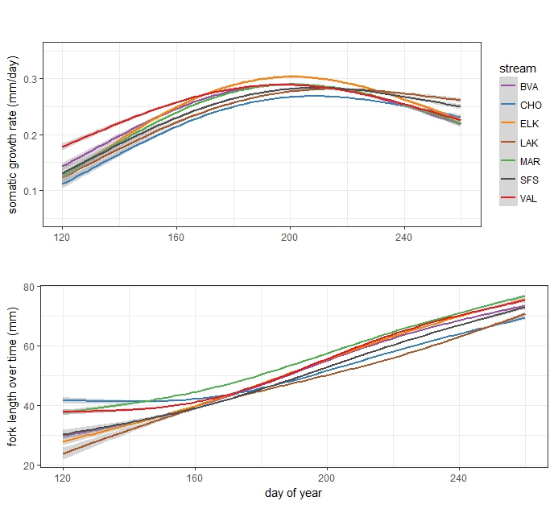

Figure 4. Top plot: Average daily otolith increment growth somatic growth of Chinook in each of the seven streams from the beginning of May to their capture dates in mid September. Bottom plot: Average fork length of Chinook in each of the seven streams from the beginning of May to their capture dates in mid September. Otolith measurements were taken to fry emergence dates whenever possible.

Average growth rate was normally distributed across average water depth measurements in the streams, with depths of about 0.5 meters (1.6 feet) correlated to the highest average growth rates (Figure 5). El niño/la niña intensity index concurrent with the measured growth rates, and in intensity index 3 months prior to when fish were growing also showed normal distributions when plotted with average growth rate(Figure 5). On average, the highest growth occurred during years with mild el niño conditions, or no recorded el niño or la niña(Figure 5).

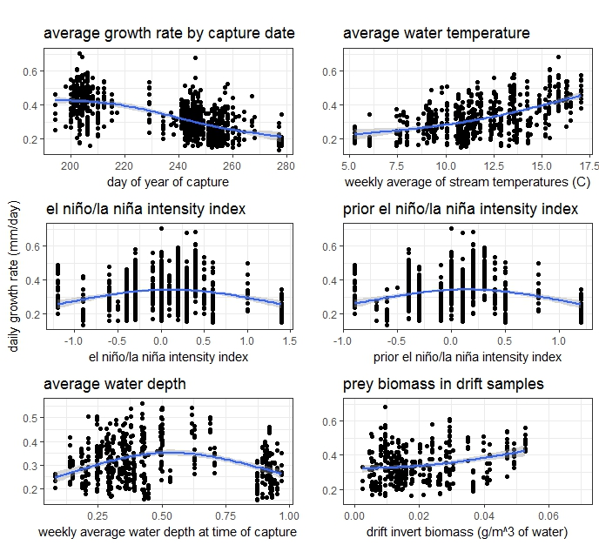

Figure 5. Average daily fish growth compared to: 1. The day of year of capture, 2. The average water temperature in the stream, 3. The el niño/la niña intensity index concurrent with the measured growth, 4. The el niño/la niña intensity index 3 months prior to the measured growth, 5. The average water depth concurrent with measured growth, 6. The biomass of available prey items in the drift concurrent with measured growth.

Invertebrate (prey) biomass in the water column was positively correlated with average growth rate (Figure 5), but was not important enough to make it into the top models. However the relationship does exist and is significant. Water chemistry in the form of total nitrogen and phosphorus, or nitrate and phosphate (NO3 and PO4) either showed no relationship to growth, or a slightly negative relationship(Figure 6).

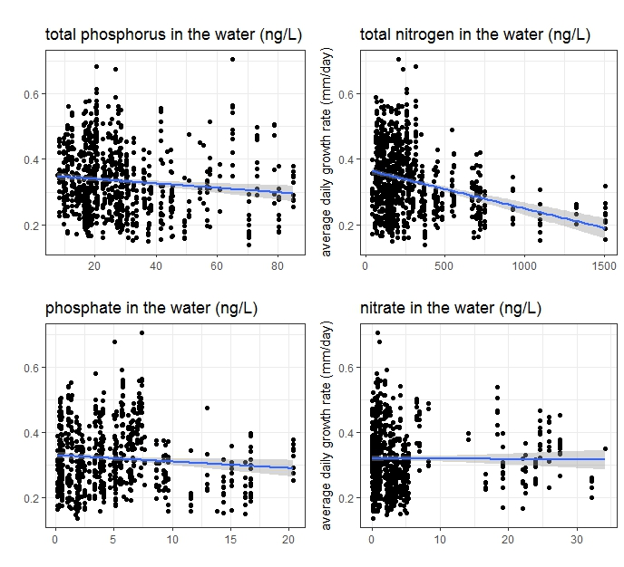

Figure 6. Top plot: The total phosphorus concentrations in the stream water plotted against the average fish growth rate (p value = 0.001). Bottom plot: The total nitrogen concentrations in the stream water plotted against the average fish growth rate (p value < 2e-16). The shaded areas represent the standard errors around the linear best fit of the data.

When fitting models to the data, Generalized Additive Models (GAM) were used to fit data that was non-linear. GAMs were used to fit lines to environmental variables that didn’t fit well with linear models when the data was plotted against fish growth. Day of year that the fish were caught, weekly water temperature average when fish were caught, el nino/la nina intensity index, and average weekly water depth when fish were caught all had clear non-linear relationships with average fish growth.

**Relationships between environmental data**

Many significant relationship existed between various environmental metrics we measured in the stream. A correlation matrix was made in order to better visualize the correlations between the various environmental variables that were measured (Figure 7). These relationships gave us confidence that we were accurately quantifying at least some of the processing occurring in these streams. Levels of nitrogen and phosphorus in the water were positively correlated with each other, as well as with primary producer productivity. Primary producer productivity was assessed by measuring both the biomass and chlorophyll concentration of biofilm and epiphytes per meter squared on the stream bed. These relationships make intuitive sense, and helped increase our confidence in our collection methods. The prey biomass and density of stream invertebrates also was positively correlated with primary producer productivity.

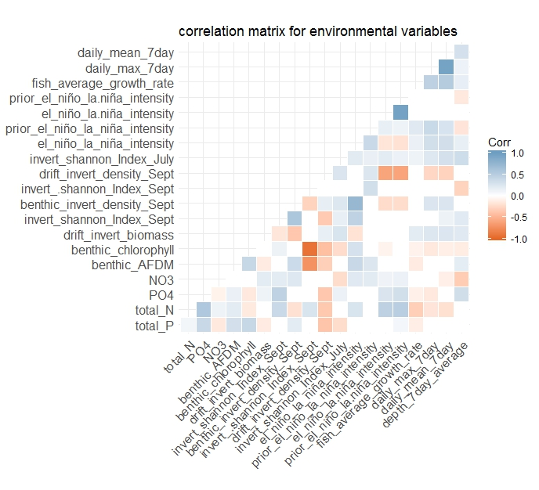

Figure 7. Plot showing the significant correlations between the various environmental variables. Red squares indicate a positive relationship, and blue indicates a negative relationship. Blank squares indicate that correlations were either not significant or nonexistent. (p values ≥ 0.05).

When environmental variables showed non-linear relationships to each other, GAMs were used to fit lines to the data. The clearest non-linear trend between the environmental data was the sinusoidal relationship between day of year and water temperature, with peak recorded temperatures usually falling between the last two weeks of July and the first two weeks of August. Other relationships between environmental variables were assumed to be linear.

**Discussion**

Climate change is predicted to decrease snowpack in the Salmon River Basin and elsewhere, leading to more variable, lower stream flows that rely more and more on rainfall. The extremely hot and dry weather in 2015 is similar to predicted weather trends in the Salmon River. This is a worrying prospect, as growth in 2015 was much lower than on average. While slightly warmer water may have helped fish in some streams grow faster, low water levels may have negated any growth benefits from this. In consistently colder streams such as Cape Horn, higher average water temperatures may actually increase somatic growth of salmonids. While in streams that have been historically warmer, higher water temperatures may surpass ideal levels, leading to a decrease in growth, as more energy is spent on base metabolic rate instead of somatic growth.

The nutrient levels in the water support the growth of the various primary producers in the stream food web. These primary producers in turn, support much of the invertebrate community that Chinook and steelhead rely on. Interestingly, stream chemistry had either no relationship, or a slightly negative relationship to fish growth, but was present in most of the top growth models. The reason for this may be that the chemical compositions of each stream were different enough to be able to relate these differences to the differences in somatic growth. While the biomass and density of the prey base in the streams was not an important variable in models describing fish growth, it did show a significant positive relationship. While food availability does seem to affect growth, it is outweighed by stream temperature and weather patterns in the models.

Stream flow itself was not in the top variables explaining growth, however it is highly related to the el niño/la niña intensity index, which was in many of the top models. The normal distribution between flow and growth is similar to the relationship between growth and the el niño/la niña intensity index. Both extremely low flows, and extremely high flows resulted in a decrease in the average growth rate, with an optimal zone existing at an intermediate flow regime.

Significant differences between average temperature and temperature response on growth rate between streams existed. Within the temperature ranges we measured, growth rate increased with temperature in all streams except LAK, which showed no relationship due to the very narrow range of temperature that was recorded. Water temperature that was recorded concurrently with growth ranged from 5 degrees Celsius to 17.5 degrees Celsius. Average water temperatures peaked in late July, several weeks after average growth rates peaked. Temperatures then steadily declined over the rest of the summer into early fall.

The thermal optima for Chinook in this study was not clearly visible. When plotted against average daily average temperature, Chinook growth does not show any indication of tapering off at the maximum recorded daily average temperatures of 17.5 degrees Celsius. The highest average daily maximum temperature recorded was 22.3 degrees Celsius. In previous studies, Chinook salmon increased heat shock protein 90 expression after a 5 hour exposure to 21.6 degree Celsius water (Palmisano et al., 2000), with mortality beginning to occur around 24 degrees Celsius(Poletto et al., 2017). The temperature response of the wild Salmon River Chinook cannot be assumed to be the same as the hatchery Chinook broodstock used in previous thermal tolerance studies. However, it can be reasonably assumed that the thermal tolerance of these wild Chinook is within the same general range.

The average daily temperatures and average daily maximum temperatures recorded in these streams came from temperature loggers anchored to substrate. Since there were not temperature loggers placed inside the fish, it is impossible to say what specific temperature a fish chose to reside in. When exposed to these possibly damaging temperatures, Chinook can either stay, or seek thermal refuges. The importance of thermal refuges provided by pools, cutbanks, and large woody debris can’t be overstated. While behavioral responses may help mitigate dangerous daytime temperature extremes, there may be an energetic cost associated with seeking shelter versus active feeding in the water column.

When individual years were modeled, stream temperature was included in the top models from 2009-2016. In some cases, stream temperature alone was the most successful at predicting growth rates. From 2003-2008, stream temperature was not in any of the top models that predicted stream growth. Interestingly, the primary temperature dataset used for this analysis was very patchy between 2003-2008. As a result, the primary temperature dataset being used was supplemented by another temperature dataset that was gathered in the same areas by different researchers. It’s possible that discrepancies between these two datasets caused the models between 2003-2008 to exclude temperature from the top models.

Fish growth was on average lowest during extreme el niño and la niña years, with highest growth during mild el niño years. During la niña years, the Salmon River Basin is cooler on average and has more rainfall. During el niño years, the Salmon River Basin experiences hotter and drier than on average. From the growth data of Chinook, it appears that either of these two climatic conditions in the extreme depress growth. During years of mild la niña, mild el niño, or neither, fish growth rate was much more variable during either extreme. Many fish still grew at the same rate as fish that experienced more extreme la niña or el niño years. However, a large percentage grew significantly faster, indicating that although a mild climate year does not guarantee higher growth, it does appear to provide more of an opportunity for it. The impact on fish from el niño and la niña conditions likely comes in the form of changes in water temperature and flow; with moderate flows and moderate temperatures providing an optimum environment for growth. The interactions of these two variables results in the normal distribution seen between the el niño/la niña intensity index and growth.

Since the climate in the Salmon River Basin is supposed to become not only hotter and dryer, but much more variable, the impact this will have on fish will likely result in growth rates lower than they have been in the past. The rearing streams in the Salmon River Basin are relatively intact compared to the main stem Snake and Columbia Rivers, which have had extensive hydropower development. The rearing phase of the Chinook life cycle helps determine the future survival success of the subsequent life stages downriver. Streams that naturally produce larger Chinook may give them a competitive advantage downstream when navigating predator dense reservoirs. Which current streams consistently produce larger fish may shift in the future as temperature and flow patterns change. This study adds to the body of knowledge on the effect of rearing conditions on Chinook, and specifically that of Salmon River Chinook. From a management and modeling perspective, being able to predict some amount of growth and body condition based on climatic data is extremely useful. Future studies should incorporate downriver survival data with growth and environmental metrics from natal streams.

**Acknowledgements**

The Idaho Wild Fish crew spent countless hours over the years collecting the temperature and PIT tag data that are used in this study. In addition to the core crew, dozens of volunteers and techs have devoted summers to helping make the project possible. In particular, the authors would like to thank Steve Achord, Matt Nesbit, Jesse Lamb, and Lewis Tullos for their work on this project.